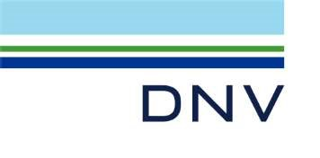

Certificate no.:

n2012975-tox

DNV ID no.:

10129500

Date of issue:

2024-12-06

Particulars of organisation

Name:

Fagskolen i Finnmark, studiested Nordkapp

Address: Klubbveien 9

9750 Honningsvåg NORWAY

Branch offices, if applicable

Name Address

This is to certify:

that the management system of the organisation has been audited and that it complies with the requirements of:

DNV-ST-0029 Maritime training providers

Areas of Activity/Capacity of Training Provider:

Maritime Training Centre Maritime Simulator Centre Maritime Academy

Offshore Training Centre Offshore Simulator Centre

This Certificate is valid until 2029-10-31, subject to annual verification.

Completion date of audit on which this Certificate is based: 2024-12-06

Issued at Nordkapp, Norway on 2024-12-06

for

DNV

This document is signed electronically in accordance with IMO

FAL.5/Circ.39/Rev.2. Validation and authentication can be obtained from

trust.dnv.com by using the Unique Tracking Number (UTN):

n2012975-tox and ID: 10129500

Olaf Rune Nilssen

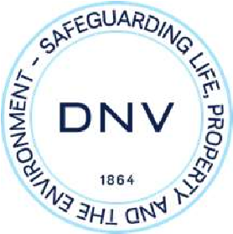

LEGAL DISCLAIMER: Unless otherwise stated in the applicable contract with the holder of this document, or following from mandatory law, the liability of DNV AS, its parent companies and their subsidiaries as well as their officers, directors and employees (“DNV”) arising from or in connection with the services rendered for the purpose of the issuance of this document or reliance thereon, whether in contract or in tort (including negligence), shall be limited to direct losses and under any circumstance be limited to 300,000 USD.

Form code: MTP 301 Revision: 2024-10 www.dnv.com Page 1 of 2

UTN: n2012975-tox

that, at an annual audit as required by the Standard, the Management System was found to comply with the relevant requirements of the Standard.

First annual audit: Place: Date:

Signature:

Stamp

Second annual audit:

Place:

Date:

Signature:

Stamp

Third annual audit:

Place:

Date:

Signature:

Stamp

Fourth annual audit:

Place:

Date:

Signature:

Stamp

Certificate no.:

n2012975-tox

Date of issue:

2024-12-06



Endorsement for annual audits

S

THIS IS TO CERTIFY:

Form code: MTP 301 Revision: 2024-10 www.dnv.com Page 2 of 2